Rating Wheat Varieties for Hessian Fly Resistance. McGregor, TX, 2015.

Shane McLellan, Carlos Campos and Allen Knutson

Texas A&M AgriLife Extension
Summary: The relative resistance to Hessian fly was rated among 22 standard and new wheat varieties grown in a non-replicated strip test near McGregor, TX. The Hessian fly infestation at this site was high, with the highest infestation averaging 0.8 Hessian fly per tiller and 32% of the tillers were infested. Six varieties, Duster, Cedar, Coker 9553, Gallagher, TAM 114 and CJ, had less than 0.1 Hessian fly per tiller. Two years of data (2014 and 2015) are available for 13 varieties which provide greater confidence in the results. The average two year rank was lowest (least number of Hessian fly) for Duster, Gallagher, Cedar and Greer. These results suggest that these four varieties have resistance to Hessian fly at this location.

Objectives: Hessian fly is an occasional insect pest of wheat in the Texas Blacklands. Once plants are infested with Hessian fly larvae, there are no means of killing the larvae to avoid crop loss. The risk of Hessian fly infestation can be reduced by delayed planting to escape early fall infestations and the planting of wheat varieties with resistance to Hessian fly. However, the resistance to Hessian fly of new varieties is often unknown. Also, resistance may vary geographically depending on local Hessian fly biotypes. The objectives of this study were to compare Hessian fly infestations among standard and new wheat varieties and identify those varieties with resistance to Hessian fly in the northern Blacklands.

Methods and Materials: This non-replicated strip test was planted October 20, 2014 near McGregor, TX. Hessian fly infestations were sampled on April 9, 2015 by collecting plants from 5 sites per plot. All of the tillers from 2 plants / site (10 plants per plot) were examined for Hessian fly pupae and larvae, for a total of 44-106 tillers per plot (variety). Thirteen of the 22 varieties rated in 2015 were also rated in 2014 at this location. These varieties were ranked for Hessian fly infestations in each year and then ranked based upon the average two year rank, with a rank of 1 having the least number of Hessian fly.

Results and Discussion: The average number of Hessian fly larvae and pupae per tiller for each of the 22 varieties is shown in the Figure. The 2015 Hessian fly infestation at this site was high, with the highest infestation (25R39) averaging 0.8 Hessian fly per tiller and 32% of the tillers were infested. However, very little Hessian fly damage (stunted tillers, lodging) was evident on the sample date.
As this was not a replicated plot, it is possible (but not likely) that some varieties with few Hessian fly may have escaped infestation. However, two years of data (2014 and 2015) are available for 13 varieties which provide greater confidence in the results. The average two year rank was lowest (least number of Hessian fly) for Duster, Gallagher, Cedar and Greer. These results suggest that these four varieties have resistance to Hessian fly at this location.

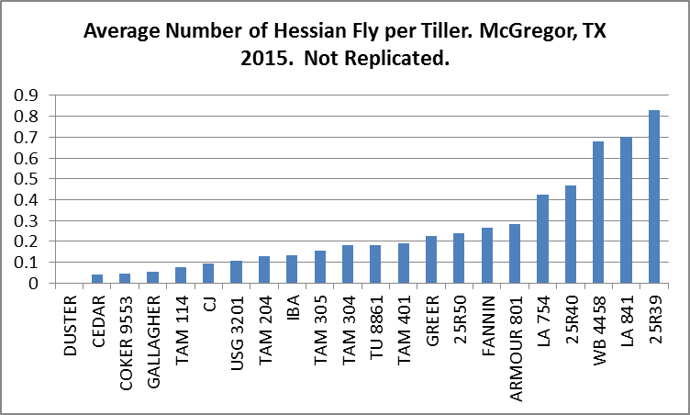

Ranking of Wheat Varieties for Hessian Fly Resistance.
McGregor, TX. 2014, 2015
Variety | Rank 2014 | Rank 2015 | Two Year Rank
Duster | 1 | 1 | 1
Gallagher | 1 | 3 | 2
Cedar | 4 | 2 | 3
Greer | 3 | 6 | 4
25R40 | 2 | 9 | 5
Coker 9553 | 9 | 3 | 6
Fannin | 6 | 7 | 7
IBA | 11 | 4 | 8
Tam 305 | 10 | 5 | 8
Armour 801 | 7 | 8 | 8
25R39 | 5 | 12 | 9
L 841 | 8 | 11 | 10
WB 4458 | 12 | 10 | 11

Acknowledgements: Thanks to Niemeier Farms for their assistance with this study. This project was funded by a grant from the USDA-RAMP program.

